PERSONAL PROFILE

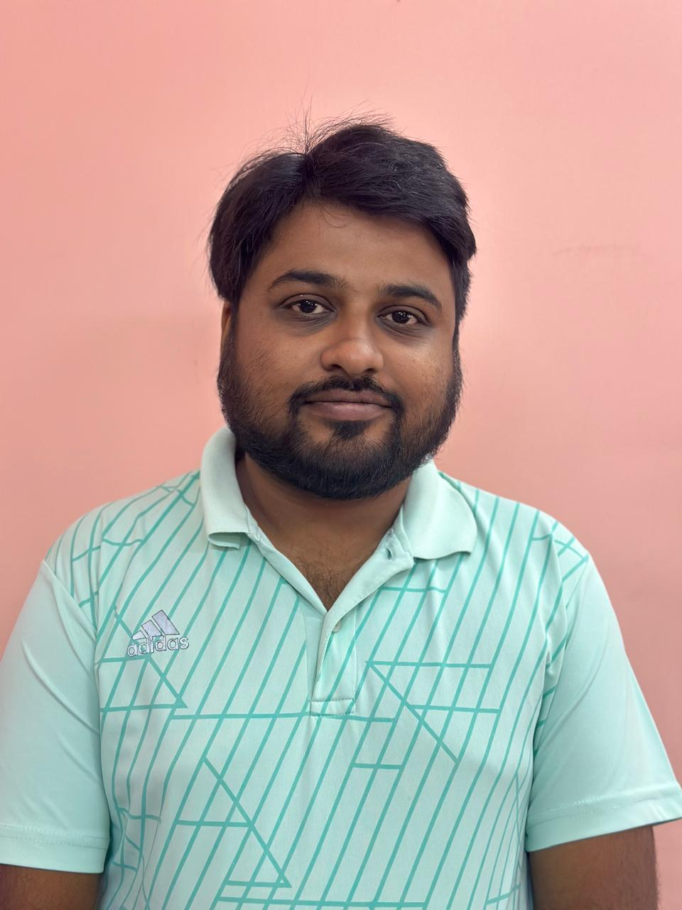
Recent Photograph

Name:- Dr. Saswata Kusari

Designation:- Assistant Professor

Date of Birth:- 07.02.1989

Educational Qualification:-
Sl No. | Degree obtain  (Abbreviation of the degree) | College/ university from which the degree was obtained | Year of Passing
1. | M.A. | WBSU | 2011
2. | Ph.D | University of Kalyani | 2019

Permanent Address:- Jaffarpur, Rabindrapally, Nonachandanpukur, Barrackpore, Kol- 122

Contact Number:- 9073169383

E-mail:- sas2340@gmail.com

Date of joining(Service):- 19.01.2016

Specialization:- Masculinity Studies, Cultural Studies

Area of Interest:- Gender and Literature

Faculty Development Programme:-
Sl No. | Year | Name of Programme Participated (OP/ RC/FDP/Summer School/FEP/Others) | Organized By
1. | 2019 | RC on Natural and Man-Made Disaster | University of Burdwan
2. | 2020 | 129th Orientation Programme | University of Calcutta

Books and Monographs :-
Sl  No. | Year  Of Publication | Title | Publisher & ISBN No.
1. | 2022 | Funny Boy: A Critical Companion | Books Way  9789352251384

